Tome Literacy Week 2023: Choose to Shine/ February 6-10 / Sponsored by Tome Club
Don’t forget to vote for your favorite Tome It List book at www.tomesociety.org/vote
Student’s FIRST Name: ________________________ Student’s LAST Name: ________________________ Grade:_________

Monday – PRINT Literacy  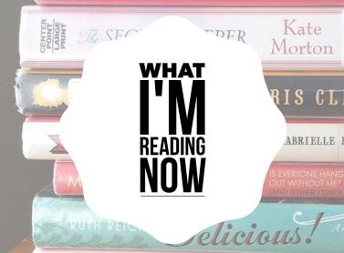 | Recommend what you Read! Flipgrid, tweet or Instagram tag a picture of you with the cover of the book you are reading. On Flipgrid, Twitter or Instagram tag @_______________ and use the #TomeLiteracyWeek  Don’t have social? Share your pic on google docs with _________@gmail.com, title your pic “Print Literacy.”  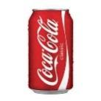  - Win on Monday– The first 100 students to come to the library on MONDAY with proof of their Book Recommendation tweet or Instagram post or google share will win a cold refreshing soft drink.  FIRST Name: _______________________ LAST Name: _______________________ Grade:____
Tuesday – VISUAL Literacy  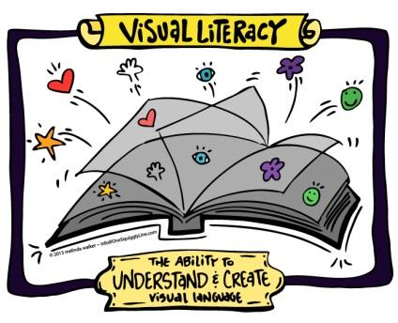 | Create Meaningful Images! Use a free phone app like Typorama or a free website like picmonkey.com to create a picture with text. Your picture should represent one cool thing you learned at school recently. Post the picture to Instagram and tag @_______________ #TomeLiteracyWeek  OR share the picture on google docs with _________@gmail.com . Title your pic “Visual Literacy.”  - Win on Tuesday – The first 100 students to come to the Library with proof of their InfoPic will win a “Color-Your-Own Bookmark!”  FIRST Name: _______________________ LAST Name: _______________________ Grade:____
Wednesday – INFORMATION Literacy  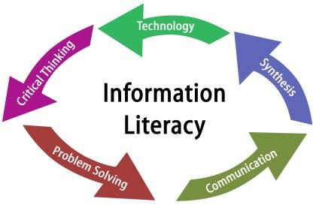 | Do GOOD Research! Do a Google or www.sweetsearch.com search for information about the 1956 U.S. Presidential Election. Select a trustworthy website from the list of results to locate the answers to these questions:  - Who was the president elected in 1964? _______________________________  - What party did he represent? ________________________________________  - How many electoral votes did he get in the election? _____________________  - Win on Wednesday – The first 100 students to come to the Library with correct answers will win a sweet treat.  FIRST Name: _______________________ LAST Name: _______________________ Grade:____
Thursday – CREATIVE Literacy  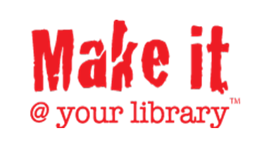 | Make something new and unique out of random materials! Your creation is as limitless as your creativity -- It could be a bookmark or origami, something useful or a piece of art. Come by the Library Learning Commons and show off your creation. (Also, we will have a makerspace with supplies if you want to come and create IN the library.) We will take a picture of your creation in the Library and post to our Instagram @_______________ #TomeLiteracyWeek  - Win on Thursday – The first 100 students who bring or come to the Library to make a creation win a cold, refreshing soft drink!  FIRST Name: _______________________ LAST Name: _______________________ Grade:____
Friday – DIGITAL Literacy | Learn good “Netiquette!” Go to YouTube and do a search for “Netiquette for Students.” Select a few of the videos on the first page of results to watch. In 140 characters or less, type something you learned in a Twitter Tweet to @_______________ #TomeLiteracyWeek Or, share your response with _________@gmail.com with the title “Digital Literacy.”  - Win on Friday – The first 100 students who bring or come to the Library to show off their Tweets will win a sweet treat!  FIRST Name: _______________________ LAST Name: _______________________ Grade:____

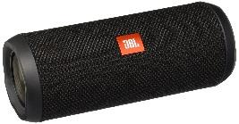
Win all week! Bring this scavenger hunt, and proof of your activity each day, to the Learning Commons and the first 100 students will WIN each day. PLUS, every student who participates each day will be entered in a drawing for a portable wireless waterproof speaker for your phone/tablet. You can be entered in the drawing up to 5 times, once for each activity completed Mon. – Fri.
Don’t forget to vote for your favorite Tome It List book at www.tomesociety.org/vote

