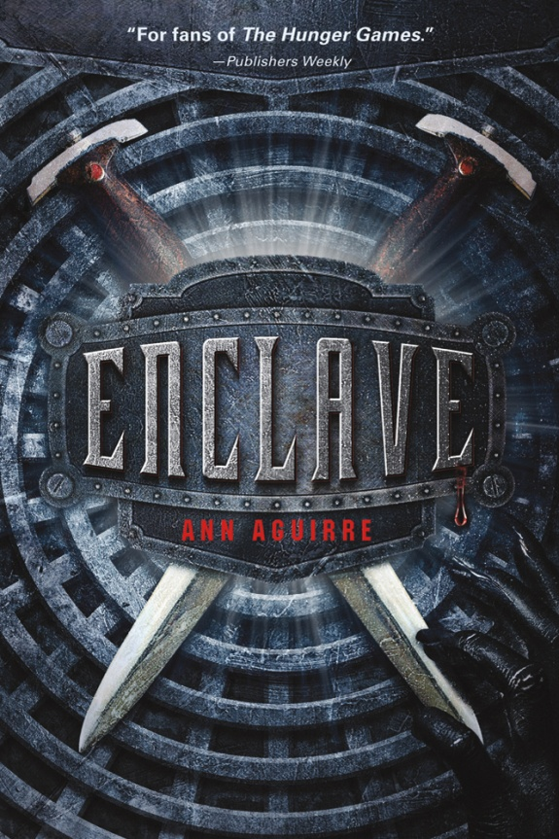
Before reading:
What does the word enclave mean? If no one knows, have someone look it up in the dictionary. From the definition, can you guess what the book might be about?
Look at the cover of the book. What does it remind you of? What can you infer about the book’s story and topics from the illustrations? Don’t forget to look at the back cover.
Read the story summary on the inside of the book jacket. Can you make any predictions about the characters and what challenges they may experience?
Have you ever been partnered with someone that you did not get along with? How did you overcome your dislike to get the task done? Did your relationship improve?
If you lived a life underground, what are some of the things that would amaze you once you came above ground? What would you like/dislike?

After reading:
In the Enclave, the characters are divided up into Hunters, Breeders, and Builders. Which of these distinctions do you believe to be most important to the society? Why?
There were also Elders like Whitewall and the Wordskeeper. Do you think the underground society could have been successful given different rulers? Or do you feel they needed a different governing structure to be successful?
Do you think the crime of hoarding and theft deserved the punishment of being banished from the Enclave?
Why do you think the Elders didn’t listen to the reports that the Freaks were growing stronger and becoming smarter?
Why do you think Fade didn’t leave the underground once he got older and more experienced? Why did he wait until Deuce was being banished to leave?
What are your feelings about Stalker? Would you have let him go with you once you left the city or would you have left him behind?
The author mentions that the world was destroyed by biological warfare or plague. Do you think this could really happen? Do you think the outcome as described by the author could be realistic?
If you could write an epilogue to the novel, what would happen to Fade, Deuce, Stalker, and Tegan in Salvation?

